भारतमौसमविज्ञानविभाग | India Meteorological Department

Thursday,05th June 2025 (15 Jyeshtha 1947 Saka)

Summary of observations recorded at 0830 hoursIST: The Northern Limit of Monsoon continues to pass through 17.0°N/55°E, 17.5°N/60°E, 18°N/65°E, 18.5°N/70°E, Mumbai, Ahilyanagar, Adilabad, Bhawanipatna, Puri, Sandhead Island, 23.5°N/89.5°E, Balurghat, 30°N/85°E. The Western Disturbance as trough in middle & upper tropospheric levels with its axis at 5.8 km above m. s. l. roughly along Long. 78°E to the north of Lat. 24°N. The upper air cyclonic circulation over south Punjab & neighbourhood lay over south Haryana & neighbourhood at 1.5 km above
m. s. l. The upper air cyclonic circulation over north Bangladesh & neighbourhood at 0.9 km above m. s. l. persisted. The north-south trough ran roughly along Long. 88°E to the north of Lat. 22°N at 3.1 km above m. s. l. persisted. An upper air cyclonic circulation lay over central Pakistan & adjoining northwest Rajasthan at 0.9 km above m. s. l. at 0530 hours IST of today. It persisted over the same region. A trough runs from south Chhattisgarh to north Bangladesh across interior Odisha, cyclonic circulation over Jharkhand & adjoining south Bihar, northern parts of West Bengal at 1.5 km above mean sea level at 0530 hours IST of today. it persisted over the same region. An upper air cyclonic circulation over Jharkhand & adjoining south Bihar at 1.5 km above mean sea level at 0530 hours IST of today. It merged with the above trough. An upper air cyclonic circulation over north interior Karnataka & adjoining Marathwada and Telangana at 0530 hours IST of today. It persisted over the same region and extended between 3.1 and 4.5 km above m. s. l. The upper air cyclonic circulation over south Gujarat & neighbourhood became less marked. The upper air cyclonic circulation over northeast Assam & neighbourhood became less marked at 0530 hours IST of today. An upper air cyclonic circulation lay over Haryana & neighbourhood at 1.5 km above mean sea level at 0530 hours IST of today. it became less marked.
Day temperatures were appreciably above normal (3.1°C to 5.0°C) at isolated places over Gangetic West Bengal, Coastal Andhra Pradesh & Yanam and Tamil Nadu, Puducherry & Karaikal. above normal (1.6°C to 3.0°C) at isolated places over Andaman & Nicobar Islands, Nagaland, Manipur, Mizoram & Tripura, Odisha and East Madhya Pradesh. near normal (-1.5°C to 1.5°C) at many places over Assam & Meghalaya and Kerala & Mahe; at most places over Arunachal Pradesh, Saurashtra & Kutch, Coastal Karnataka and Lakshadweep; at few places over Sub Himalayan West Bengal & Sikkim, East Uttar Pradesh, West Rajasthan, Konkan & Goa, Rayalaseema and South Interior Karnataka; at isolated places over Bihar, West Uttar Pradesh, Himachal Pradesh, Gujarat Region and Chhattisgarh. Yesterday, the highest maximum temperature of 41.1°C was reported at Rajkot (Gujarat).
Hailstorm observed at isolated places over Himachal Pradesh (Shimla), Punjab (Ludhiana) and Haryana (Kaithal).

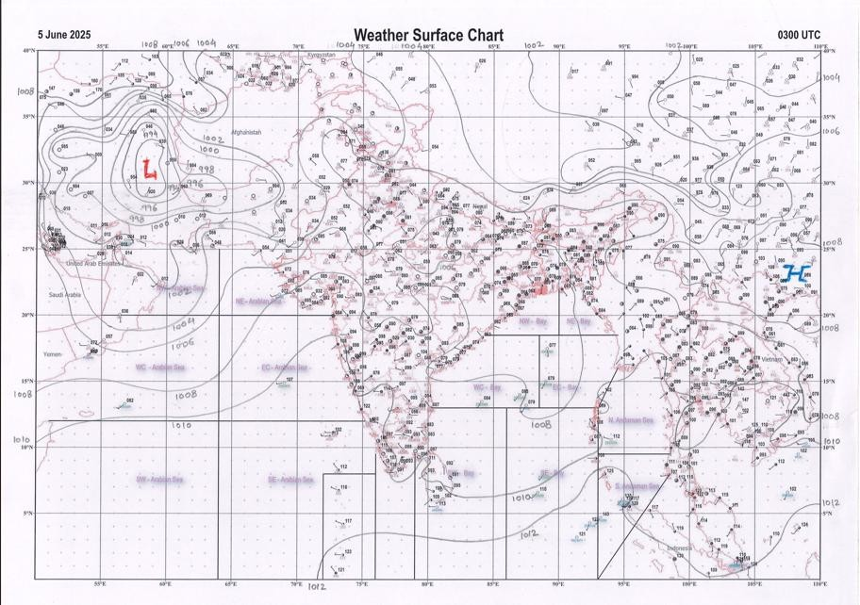 | 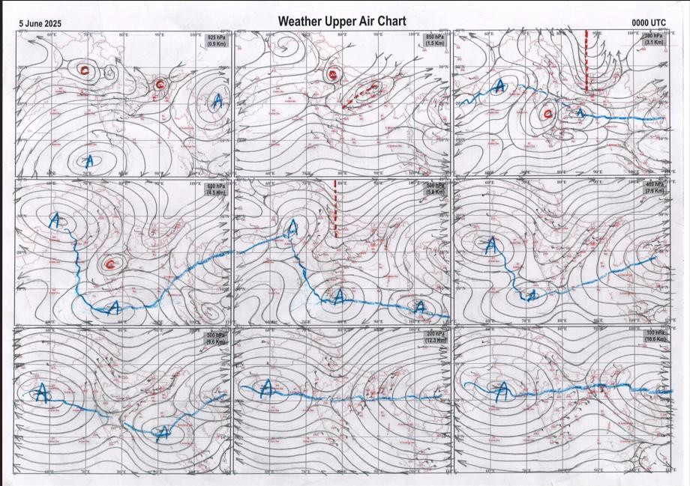
g.1. Analysed surface chart based on 03z observation | Fig.2. Analysed upper air chart based on 00z observation

CR & S Office, Pune Issued at 1245 hrs. IST | Weather Forecasting Division CR&S, Pune

Indian regions | Realised rainfall (chief amount in cm during past 24 hrs):
East | many places: Assam & Meghalaya#, Nagaland-Manipur-Mizoram-Tripura and Gangetic West Bengal a few places: Arunachal Pradesh, Sub-Himalayan West Bengal & Sikkim, Odisha and Jharkhand+ dry weather: Bihar  Mawkyrwat 21.0, Mawsynram 18.0, Cherrapunji (rkm) 15.6, Sikatia 7.4, Jarmindi 7.0, Kandi 6.0, Bhuban 5.7, Bolagarh 5.4, Saiha AWS 4.9, Saiha & Bhubaneswar AP 4.4 each, Seppa AWS & Tilpara barrage 4.3 each, Berhampore 4.2,  Naharlagun AWS 4.1, Tadong 3.8, Gangtok 3.7, Nagarkata 2.3, Jamshedpur 1.4, Kailashahar AP 0.8, Pasighat AP 0.2.
North | a few places: Uttarakhand, Punjab and Himachal Pradesh  isolated places: Uttar Pradesh, Haryana, Jammu-Kashmir and Ladakh and Rajasthan  Nagrota surian 5.9, Uska bazar fmo 5.2, Bharatgarh 4.6, Pilani 3.7, Chirawa & Sawaimadhopur tesil SR 3.2 each, Rae bareli CWC 3.0, Ludhiana 2.8, Doraha irr & Lolab 2.2 each, Nowgam 2.1, HMO shillaro 2.0, Uklana rly 1.8, Ranikhet (g) & Mahendragarh AWS 1.7 each, Deoprayag 1.6, Narnaul, Dungargarh & Ladnoo 1.5 each, Fursatganj 1.4, Shahjahanpur (t) & Simla 1.1 each, Shahjahapur 1.0, Gulmarg RS 0.8, Dharchula 0.7, Churu tehsil SR 0.4.
Central | isolated places: Madhya Pradesh, Vidarbha and Chhattisgarh  Nainpur 5.1, Amla 4.8, Khachrod 4.6, Patharia 3.6, Bijapur 3.5, Damoh-aws 3.1, Kapu 2.9, Sindewahi 2.0, Jashpurnagar 1.4, Armori 0.9, Bairagarh airport 0.5, Bramhapuri 0.2.
Peninsula | most places: Konkan & Goa+  many places: coastal Karnataka  a few places: Madhya Maharashtra and Kerala  isolated places: Gujarat State, Marathwada, coastal Andhra Pradesh, Telangana, Rayalaseema◆, Tamil Nadu and interior Karnataka  Mhasla 7.5, Tala & Gaganbawada 4.9 each, Alibag IMD part time 4.8, Shahuwadi 4.5, Kadra 3.8, Rasipuram & Kurudamannil 3.5 each, Kumarakam 3.4, Kallandri 3.3, Castle rock 2.8, Palasa 2.6, Vepada 2.5, Satara 2.4, Afzalpur HMS 2.3,  Jalalpor, Navasari AWS & Tondi 2.2 each, Agumbe emo 2.0, Lohara 1.9, Kottayam 1.8, Honavar 1.5, Shiggaon 1.1, Shihor & Kamareddy 0.9 each, Kathlapur 0.8, Dharwad PTO & Koppa 0.7 each, Dharashiv IMD parttime, Ausa & Harapanahalli  0.6 each, Valsad & Nizamabad 0.5 each, Umrala & Tada 0.2 each, Tirupati AP 0.1.
Islands | a few places: Andaman & Nicobar  isolated places: Lakshadweep◆  Nancowry 1.5, Iaf carnicobar 0.7, Minicoy 0.2.
Table 2. Forecast / warnings (distribution of rain / thundershowers) for 7 days (valid from time of origin upto 0830 hrs IST of next day)
Sr. No | Sub-division Name | Day 1 | Day 2 | Day 3 | Day 4 | Day 5 | Day 6 | Day 7 | Sr.  No. | Sub-division Name | Day 1 | Day 2 | Day 3 | Day 4 | Day 5 | Day 6 | Day 7
 |  | 05 Jun | 06 Jun | 07 Jun | 08 Jun | 09 Jun | 10 Jun | 11 Jun |  |  | 05 Jun | 06 Jun | 07 Jun | 08 Jun | 09 Jun | 10 Jun | 11 Jun
1 | Andaman Nicobar Islands | F | F | W | W | W | W | W | 19 | west Madhya Pradesh | I  | I  | I  | I | I | I | I
2 | Arunachal Pradesh | F + | F | F | F | F | F | F | 20 | east Madhya Pradesh | I  | I  | I  | I | I | I | I
3 | Assam-Meghalaya | W++  | F + | S | S | F + | W + | W + | 21 | Gujarat region | I | I | I | I | I | I | I
4 | Nagaland-Manipur- Mizoram-Tripura | F +  | S  | S | S | F | F | F | 22 | Saurashtra and Kutch | I | I | I | I | I | I | I
5 | Sub Himalayan West Bengal/Sikkim | F  | F | S | S | S | S | F | 23 | Konkan and Goa | F  | S  | S  | S  | I | I | I
6 | Gangetic West Bengal | F  | I | I | I | I | I | S | 24 | Madhya Maharashtra | S  | S  | S | I  | I | I | I
7 | Odisha | I  | I + | I + | I + | I + | I | I | 25 | Marathwada | I  | S  | S | I  | I | I | I
8 | Jharkhand | I  | I | I | I | I | S | S | 26 | Vidarbha | I  | I  | I | I  | I | I | I
9 | Bihar | S +  | I | I | I | I | I | S | 27 | Chhattisgarh | I  | I  | I  | I  | I  | I | I
10 | east Uttar Pradesh | I  | D | D | D | D | D | I | 28 | Coastal Andhra Pradesh and Yanam | I + | I  | I  | I  | I  | S | S
11 | west Uttar Pradesh | I  | D | D | D | D | D | D | 29 | Telangana | I  | S  | I | I | I | I | I
12 | Uttarakhand | S  | I | D | D | D | D | I | 30 | Rayalaseema | I  | I  | I  | I | S | S | S
13 | Haryana,Chandigarh and Delhi | I  | D | D | D | D | D | D | 31 | Tamil Nadu, Puducherry and Karaikal | I + | I + | S  | S  | S  | S | I
14 | Punjab | I | D | D | D | D | D | D | 32 | Coastal Karnataka | S | S | F | F | F | W | W
15 | Himachal Pradesh | S  | I | D | D | D | D | D | 33 | North interior Karnataka | I  | I  | S  | S  | F  | F | F
16 | Jammu-Kashmir and Ladakh | I | D | D | D | D | D | D | 34 | South interior Karnataka | I  | I  | S  | S  | F  | F | F
17 | west Rajasthan | I  | D | D | D + | D + | D + | D + | 35 | Kerala and Mahe | S | S | F | S | S | F | F
18 | east Rajasthan | I  | I  | I | I | D | D | D | 36 | Lakshadweep | S | S | S | S | S | F | F
Legends: D = DryI = IsolatedS = ScatteredF = Fairly widespreadW = Widespread #= heavy to very heavy rain at a few places with extremely heavy rain at isolated places +++= heavy rain at a few places with very heavy rain at Isolated places ++= heavy to very heavy rainfall @=Isolated exceptionally heavy rainfall + = heavy rain ●/*= rain or snow ♦ = very light rain ≡=fog= thunderstorm with lightning =Squall / Gusty / gale / strong wind - =cold wave/cold day += heat wave/warm night/hot and humid weathe r=Duststorm =ground frost = Hail

Fig. 4: Districtwise warnings for five days for Maharashtra State

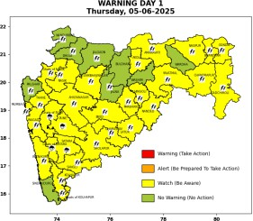 | 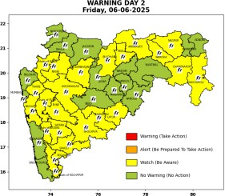 | 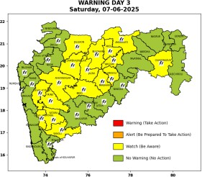 | 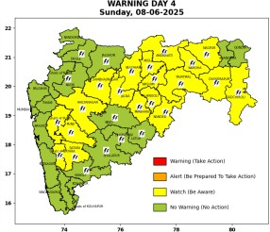 | 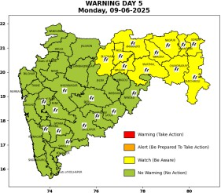

Pune, Lohegaon and Pashan observations at 0830 hrs. IST of Today
 | Temperature (°C) |  |  |  |  | Humidity (%) |  |  |  | Rainfall (mm)
 | Max. past 24 hrs | Dep. from normal | Min. past 24 hrs. | Dep. from normal | Dry Bulb | At 0830 hrs.  IST | Dep. From normal | At 1730  hrs. IST of  y’day | Dep. from normal | Past 24 hrs. | Since 1st June | Dep. from normal
PNE | 28.4 | -7.3 | 20.9 | -2.5 | 25.6 | 83 | 10 | 88 | 37 | 16.7 | 17.9 | -3.2
PSN | 27.6 | - | 20.0 | - | 25.0 | 87 | - | 97 | - | 16.7 | 16.9 | -
LHG | 30.0 | -4.0 | 23.4 | 2.4 | 27.8 | 68 | -4 | 68 | 17 | 10.0 | 14.0 | -7.8

Local (Pune and neighbourhood) forecast
Max./Min. Temperature (°C) |  |  |  |  |  |  |  |  | Weather
Date | Pune | Pashan | Lohegaon | Chinchwad | Lavale | Magarpatta | NDA | Koregoan Park
05/06/25 | 33/20.9* | 32/20.0* | 35/23.4* | 33/22.4* | 31/21.0* | 34/23.4* | 31/20.6* | 34/23.0* | Partly cloudy sky becoming generally cloudy sky towards afternoon/evening. Thunderstorm with lightning, light rain very likely.
06/06/25 | 31/22 | 31/21 | 33/24 | 31/23 | 30/22 | 33/24 | 30/22 | 32/24 | Partly cloudy sky becoming generally cloudy sky towards afternoon/evening. Thunderstorm with lightning, light to moderate rain very likely.
07/06/25 | 30/21 | 30/20 | 32/23 | 30/22 | 29/21 | 32/23 | 29/21 | 31/23 | Partly cloudy sky becoming generally cloudy sky towards afternoon/evening. Thunderstorm with lightning, light to moderate rain very likely.
08/06/25 | 30/21 | 30/20 | 32/23 | 30/22 | 29/21 | 32/23 | 29/21 | 31/23 | Partly cloudy sky becoming generally cloudy sky towards afternoon/evening. Thunderstorm with lightning, light to moderate rain very likely.
09/06/25 | 31/22 | 31/21 | 33/24 | 31/23 | 30/22 | 33/24 | 30/22 | 32/24 | Mainly clear sky becoming partly cloudy sky towards afternoon/evening. very light rain likely.
10/06/25 | 32/22 | 32/21 | 34/24 | 32/23 | 31/22 | 34/24 | 31/22 | 33/24 | Mainly clear sky becoming partly cloudy sky towards afternoon/evening. very light rain likely.
11/06/25 | 33/23 | 33/22 | 35/25 | 33/24 | 32/23 | 35/25 | 32/23 | 34/25 | Mainly clear sky becoming partly cloudy sky towards afternoon/evening. very light rain likely.
* = realized temperature
Mumbai (Colaba) |  |  |  | Nagpur (AP)
Date 2025 | T max °C | T min °C | Weather | T max °C | T min °C | Weather
05/06 | 32 | 26 | Partly cloudy sky with possibility of moderate rain or thunderstorm. Thunderstorm accompanied with lightning & gusty winds(30-40kmph). | 40 | 27 | Rain or Thunderstorm accompanied with lightning & gusty winds(30-40kmph).
06/06 | 33 | 26 | Generally cloudy sky with light rain. | 38 | 27 | rain or thundershowers with strong gusty winds.
07/06 | 33 | 26 | Generally cloudy sky with light rain. | 40 | 29 | Partly cloudy sky towards afternoon or evening. Thunderstorm accompanied with lightning & gusty winds(30-40kmph).
08/06 | 32 | 26 | Generally cloudy sky with moderate rain. | 40 | 28 | Rain or Thunderstorm accompanied with lightning & gusty winds(40-50kmph).
09/06 | 32 | 27 | Generally cloudy sky with moderate rain. | 38 | 28 | Rain or Thunderstorm accompanied with lightning & gusty winds(40-50kmph).
10/06 | 32 | 27 | Rain. | 40 | 28 | Partly cloudy sky with possibility of rain or Thunderstorm.
11/06 | 32 | 27 | Rain. | 40 | 28 | Partly cloudy sky with possibility of rain or Thunderstorm.

Rainfall Distribution |  |  | Rainfall Categories | Rainfall (mm) | Cloud condition |  | Rainfall Intensity | Range
Widespread (W) | 76-100% |  | Very Light rain | Trace to 2.4 mm | Mainly clear sky | 1-2 oktas | Light Spell | 1 cm/hr
 |  |  | Light rain | 2.5 to 15.5 mm | Partly cloudy sky | 3-4 oktas | Moderate Spell | 1-2 cm/hr
Fairly Widespread (FW) | 51 – 75% |  | Moderate rain | 15.6 to 64.4 mm | Generally cloudy sky | 5-7 oktas | Intense Spell | 2-3 cm/hr
Scattered (S) | 26 – 50% |  | Heavy rain | 64.5 to 115.5 mm | Overcast | 8 oktas | Very Intense Spell | 3-5 cm/hr
isolated (I) | 1 – 25% |  | Very heavy rain | 115.6 to 204.4 mm |  |  | Extremely Intense Spell | 5-10 cm/hr
D (D) | No Rain |  | Extremely heavy rain | ≥ 204.5 mm |  |  | Cloudburst | > 10 cm/hr
Probability Terms in %: |  |  | Heavy snow | 6.5 to 11.5 cms water equivalent of rain
unlikely | < 25 |  | Very heavy snow | 11.6 to 20.4 cms water equivalent of rain
likely | between 25 50
very likely | between 51 75
most likely | >75

